**Full Stack Development with MERN**

**Database Design and Development Report**

|  |  |
| --- | --- |
| Date | 17th July 2024 |
| Team ID | SWTID1720068764 |
| Project Name | Book Nest (Book-Store) |
| Maximum Marks | 5 Marks |

**Project Title: Book Nest**

Date: 17th July 2024

Prepared by: Sricharan R, Krishna Vamsi S, Nithin Krishna K, Praneeth P

**Objective**

The objective of this report is to outline the database design and implementation details for the **Book Nest** project, including schema design and database management system (DBMS) integration.

**Technologies Used**

* **Database Management System (DBMS):** MongoDB
* **Object-Document Mapper (ODM):** Mongoose

**Design the Database Schema**

The database schema is designed to accommodate the following entities and relationships:

**1. Users**

- Attributes: [list attributes like _id, name, email, password]

**2. Book Management**

- Attributes: [list attributes like _id, bookTitle, authorName , imageURL, category, bookDescription,

bookPDFURL,

**3. Comments**

- Attributes: [list attributes like _id, ratings, post (references Post), author (references User), occupation, feedback]

**Implement the Database using MongoDB**

The MongoDB database is implemented with the following collections and structures:

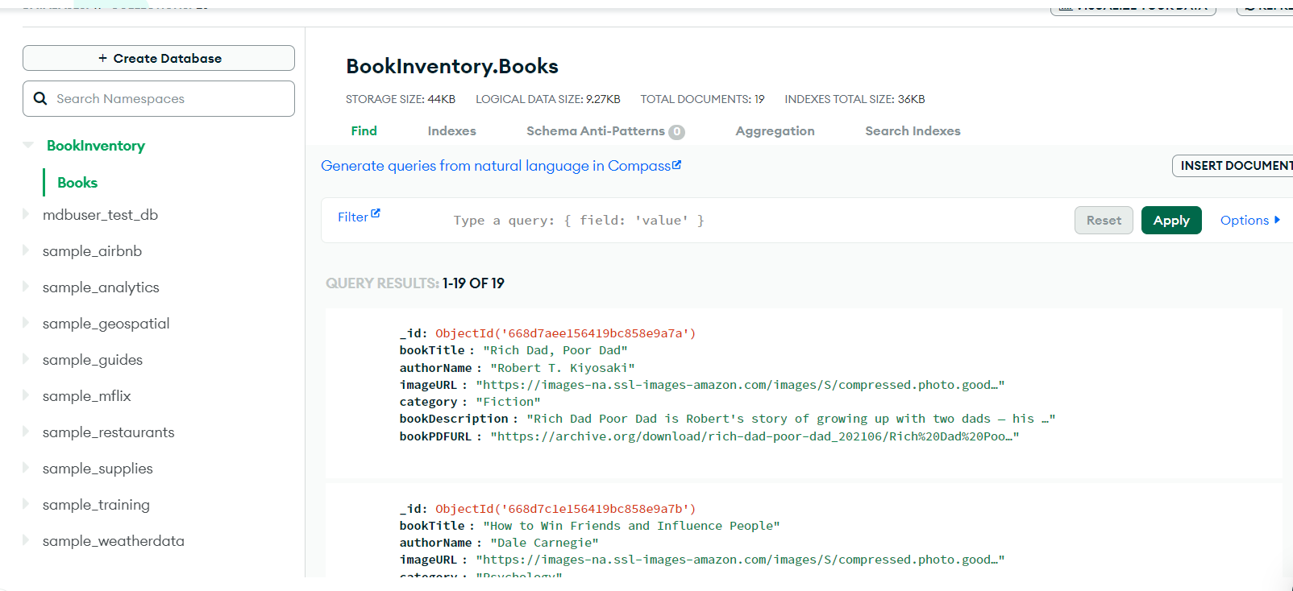

Database Name: **BookInventory**

1. Collection: **Books**

- Schema:

```

{

_id: ObjectId,

booktitle: String,

authorName: String,

imageURL: String,

category: String,

bookDescription: String,

bookPDFURL: String

}

```

```

**Integration with Backend**

* Database connection: Give a Screenshot of the Database connection done using Mongoose

